Thrombosis
Thrombosis is the clotting of blood

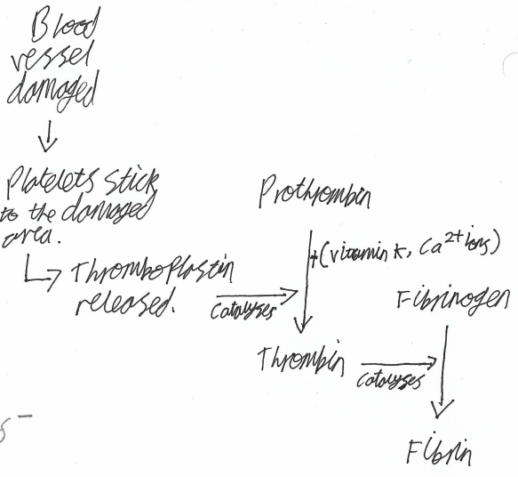

When a blood vessel is damaged:
- Platelets go to the damage and stick. The platelets release thromboplastin.
- The thromboplastin catalyses the reaction of prothrombin (which is already in the blood) into thrombin, requiring vitamin K and calcium ions.
- The thrombin catalyses the reaction of fibrinogen (which is already in the blood) into fibrin.
- The fibrin forms a mesh which captures more platelets and blood cells to form a clot, and to close the damage.

